Jasmine

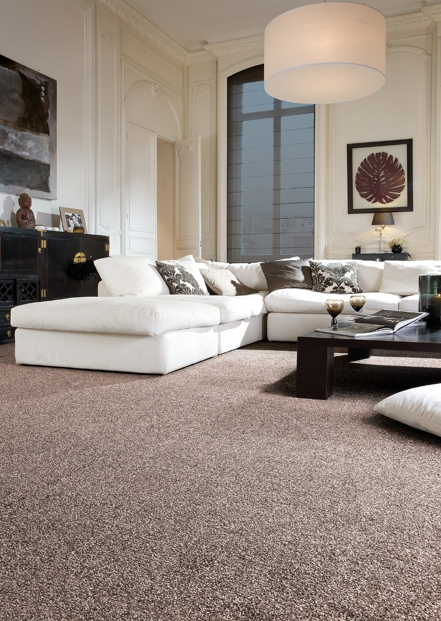
Manufacturing process
1/10” cut pile
Pile content
100 % PP
Backing
Felt
Pile weight
ca 1.150 gr./m²
Total weight
ca 2.050 gr./m²
Pile height
ca 8 mm
Total height
ca 10 mm
Tuft density
ca 189 120/m²
Width
400 + 500 cm

