Scala

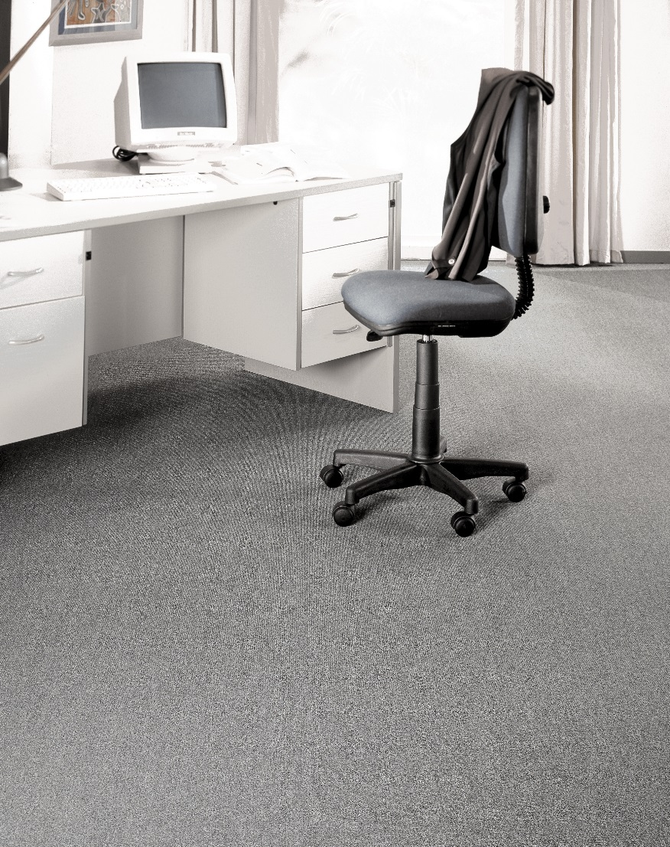
Manufacturing process
Tufting 5/32” loop pile
Pile content
100 % PP
Primary backing
Woven PP
Secondary backing
Texflor felt
Pile weight
Ca. 520 gr./m²
Total weight
Ca. 1.565 gr./m²
Pile height
Ca. 4 mm
Total height
Ca. 6,5 mm
Tuft density/m²
Ca. 105 000
Width
300 + 400 + 500 cm
Sound insulation
24 dB
Fire class
Efl (EN 13501-1)
