Divine

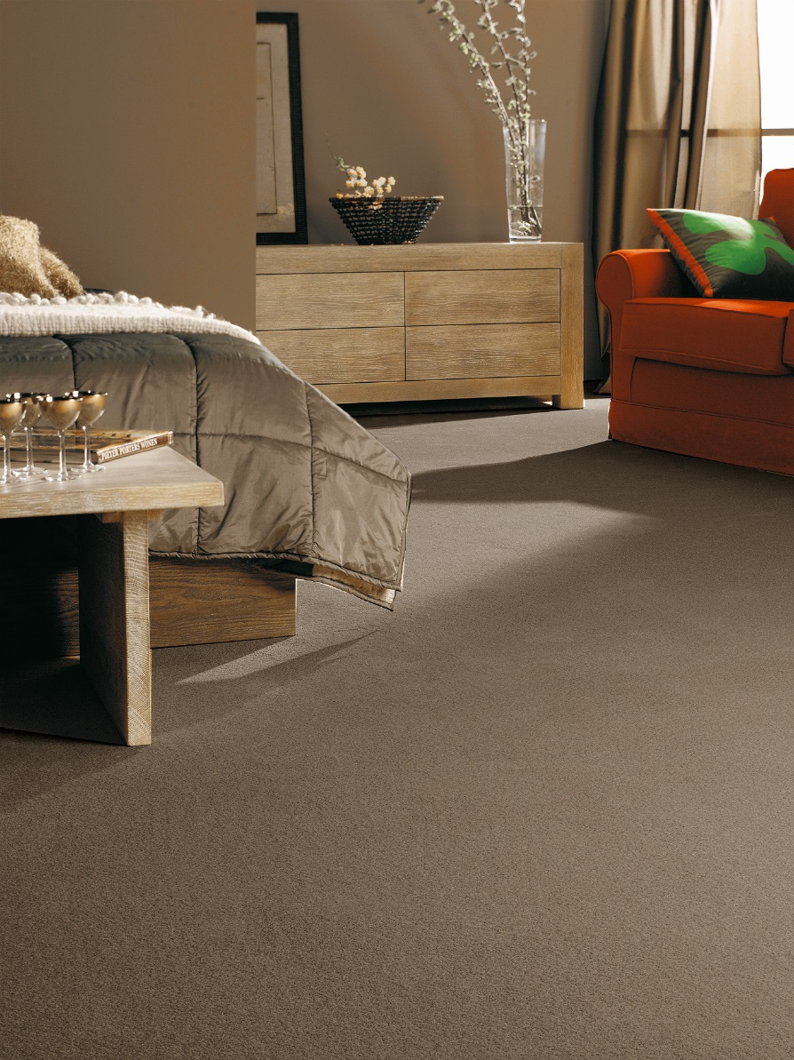
Manufacturing process
Saxony
Pile content
100 % PP
Backing
Felt
Pile weight
ca 1.700 gr./m²
Total weight
ca 2.610 gr./m²
Pile height
ca 15,5 mm
Total height
ca 17 mm
Tuft density
ca 113 400/m²
Width
400 + 500 cm

