Dublin

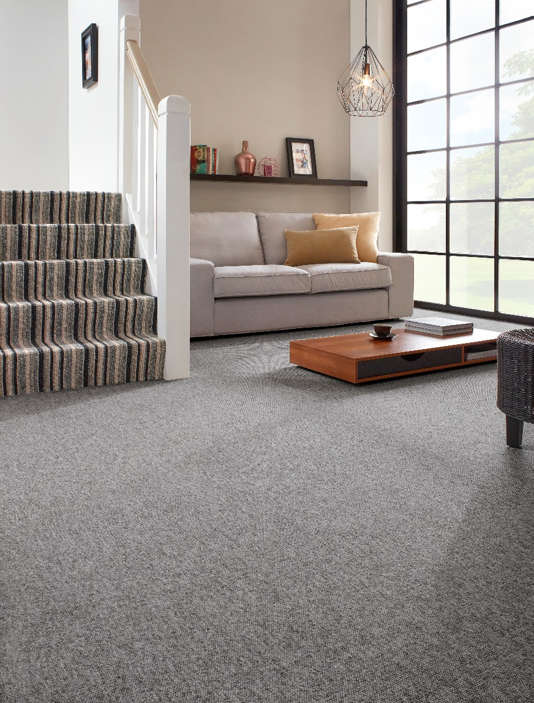
Manufacturing process
5/32” Bouclé
Pile content
100 % PP
Backing
Felt
Pile weight
ca 500 gr./m²
Total weight
ca 1.350 gr./m²
Pile height
ca 3,5 mm
Total height
ca 5,5 mm
Tuft density
ca 101 000/m²
Width
300 + 400 + 500 cm

