Durban

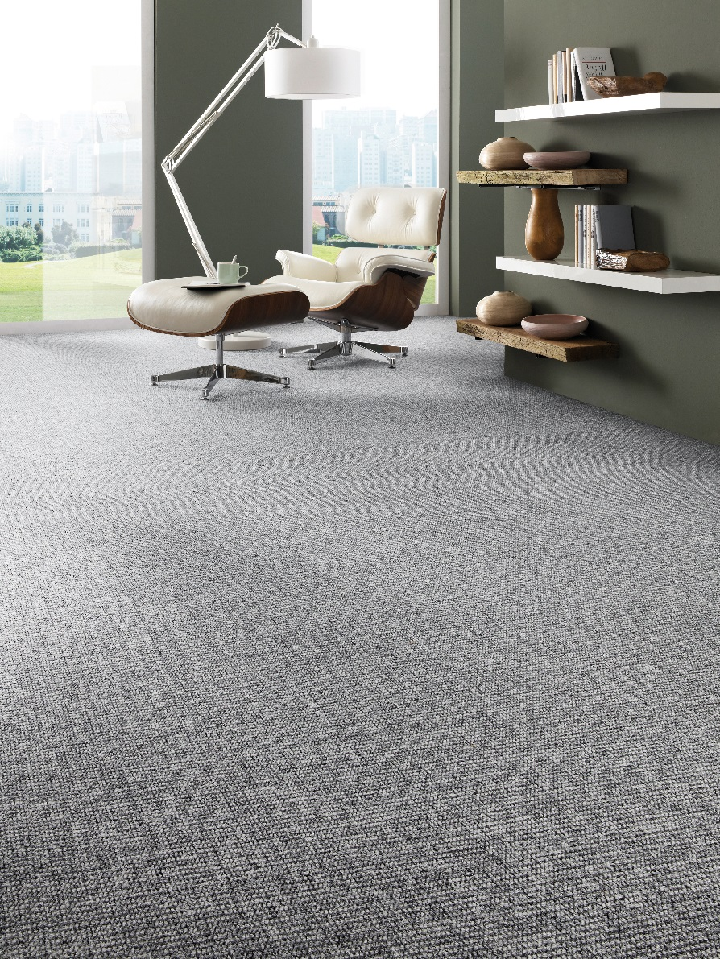
Manufacturing process
1/10” loop pile
Pile content
60 % PA/ 40 % PP
Primary backing
Twinback
Pile weight
± 660 gr./m²
Total weight
± 1.800 gr./m²
Pile height
± 3 mm
Total height
± 7 mm
Tuft density/m²
± 225 000
Width
400 + 500 cm
Sound insulation
± 22 dB
Fire class
Cfl-s1 (EN 13501-1)
only with full adhesion

