Florida

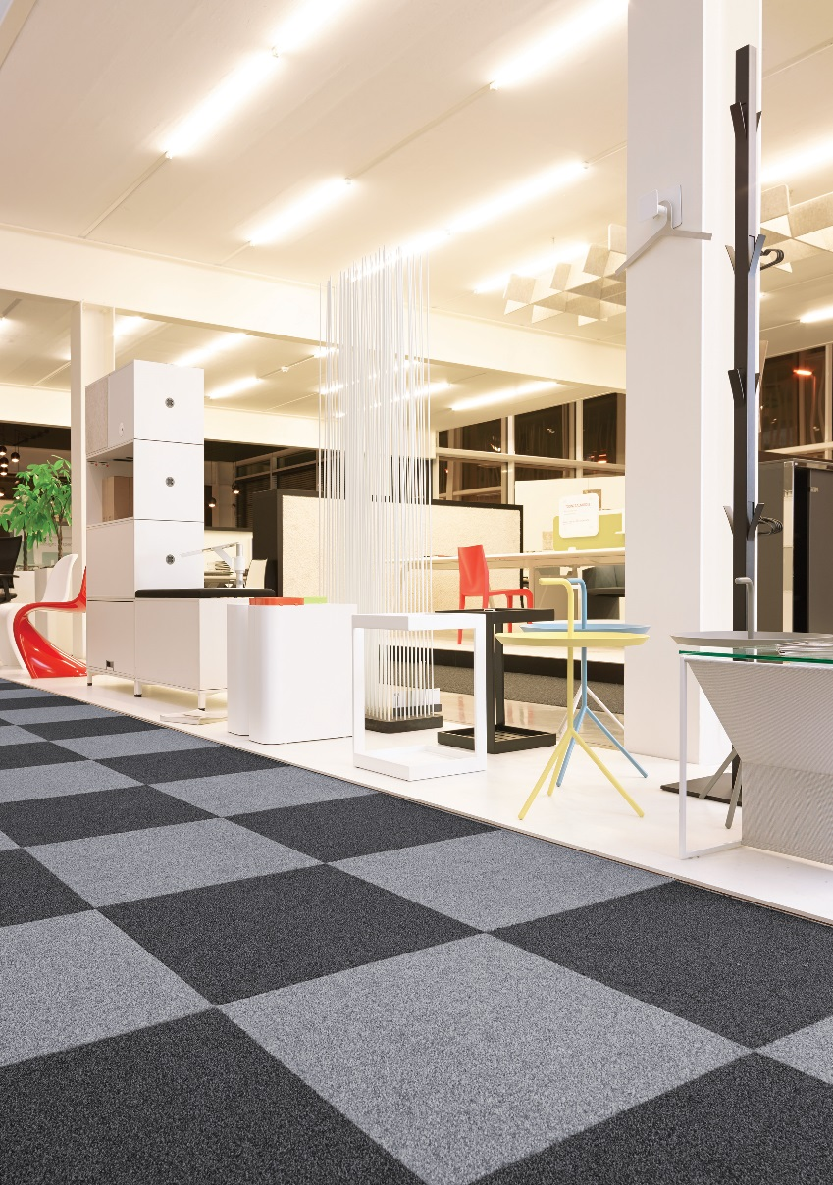
Manufacturing process
1/10” Tufted loop pile
Pile content
60 % PA / 40 % PP
Primary backing
Bitumen
Pile weight
ca. 660 gr./m²
Total weight
ca. 4.050 gr./m²
Pile height
ca. 3 mm
Total height
ca. 6 mm
Tuft density/m²
ca. 215 000
Size
50 x 50 cm

