Græs m. nop
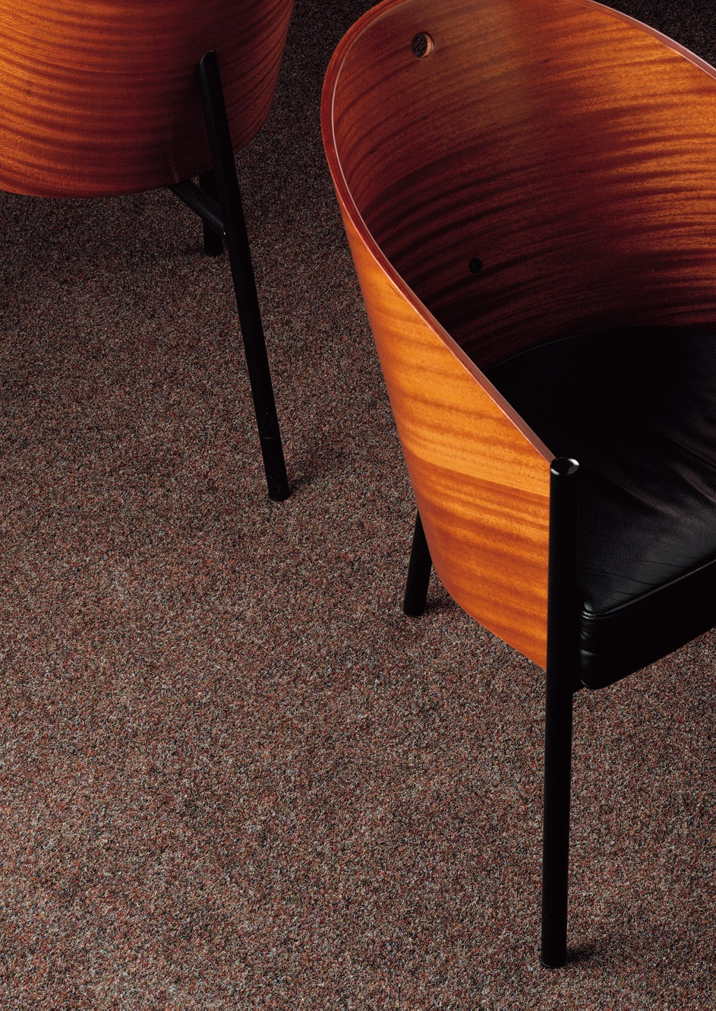
Manufacturing process
Needlefelt
Pile content
50 % PP / 50 % PES
Backing
Nops
Pile weight
ca 290 gr./m²
Total weight
ca 930 gr./m²
Pile height
ca 2 mm
Total height
ca 4,2 mm
Width
200 cm – Grøn, grå
400 cm – Grøn, antracit

