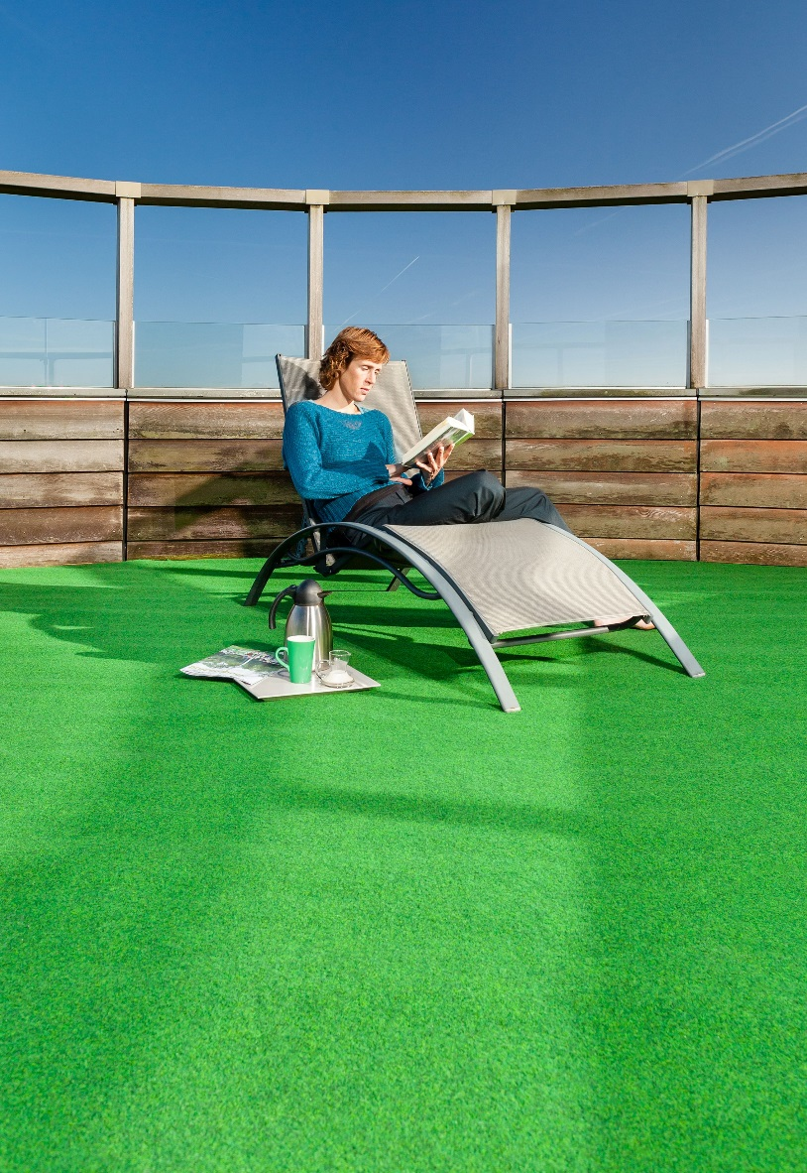
Græs u. nop
Manufacturing process
Needlefelt
Pile content
50 % PP / 50 % PES
Backing
Precoat
Pile weight
ca 290 gr./m²
Total weight
ca 900 gr./m²
Pile height
ca 2 mm
Total height
ca 3,5 mm
Width
200 cm – Grøn, grå, antracit
400 cm – Grøn

