Hawai

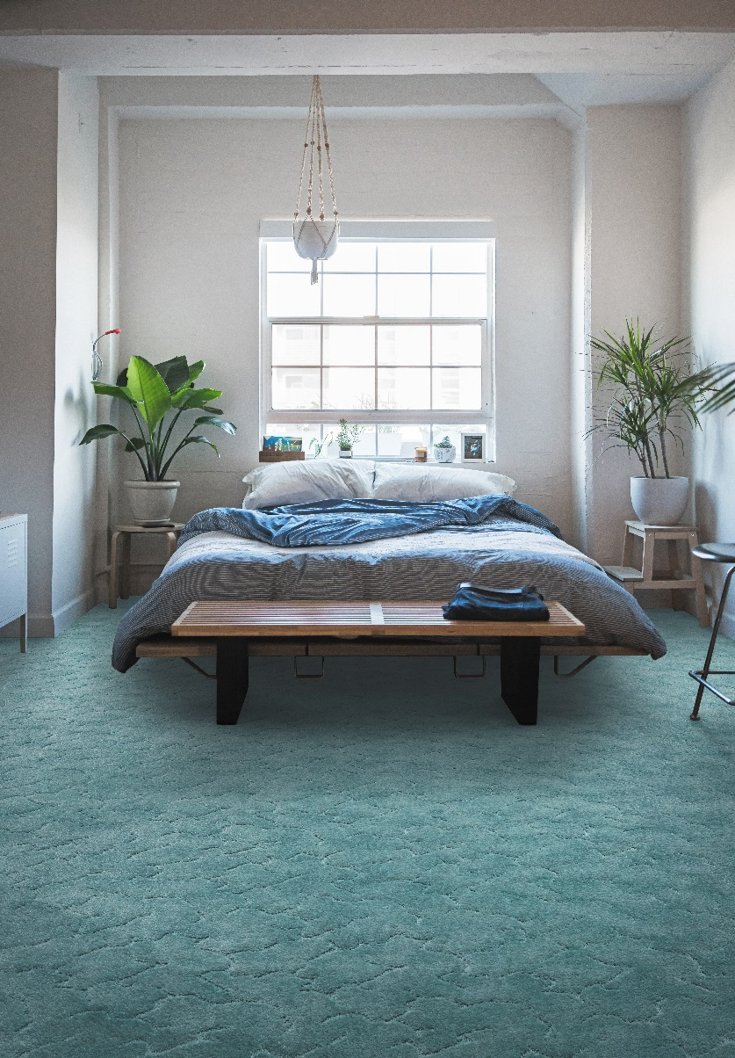
Manufacturing process
Tufting 5/32” 3D Structure
Pile content
100 % Polyamid
Backing
Texflor
Pile weight
ca 575 gr./m²
Total weight
ca 1.470 gr./m²
Pile height
ca 5 mm
Total height
ca 9 mm
Tuft density
ca 87 500/m²
Width
400 + 500 cm
Fire class
Efl (EN 13501-1)

