Lupo

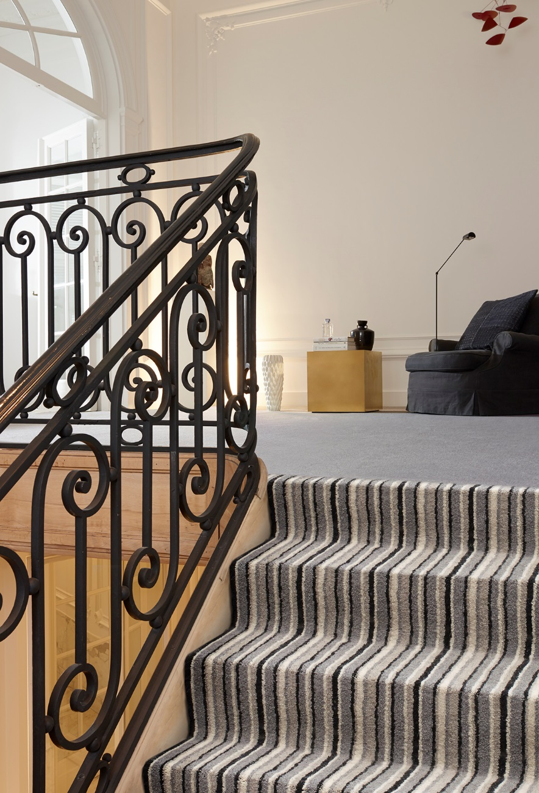
Manufacturing process
5/32” Loop pile
Pile content
100 % PP
Backing
Felt
Pile weight
ca 475 gr./m²
Total weight
ca 1.345 gr./m²
Pile height
ca 5 mm
Total height
ca 7 mm
Tuft density
ca 105 840/m²
Width
400 + 500 cm

