Infinity

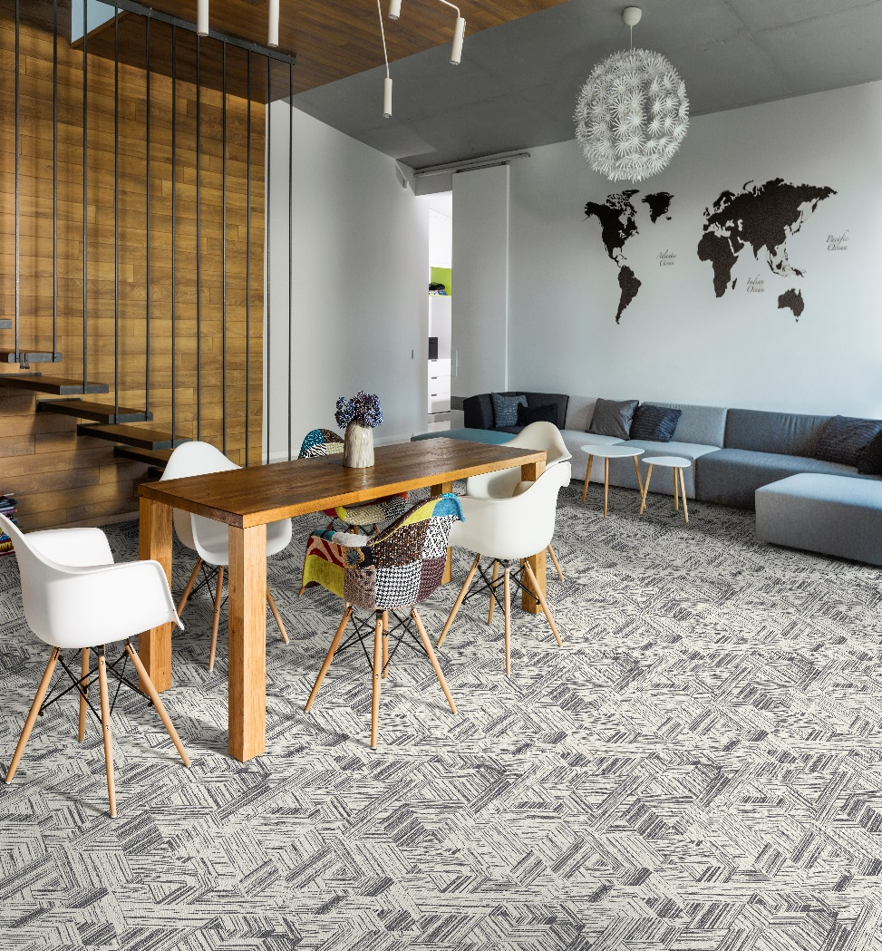
Manufacturing process
1/10” Structure
Pile content
100 % PA
Backing
Ultratex
Pile weight
ca 255 gr./m²
Total weight
ca 1.250 gr./m²
Pile height
ca 2,5 mm
Total height
ca 5,5 mm
Tuft density
ca 177 000/m²
Width
400 cm

