Montana

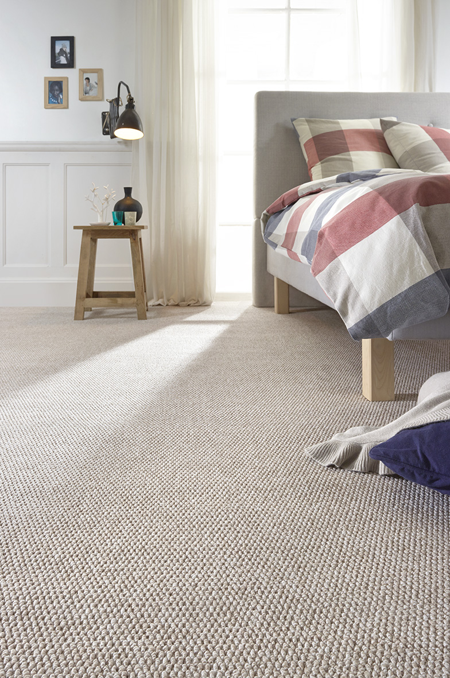
Manufacturing process
5/32” Bouclé
Pile content
100 % PP
Backing
Felt
Pile weight
ca 475 gr./m²
Total weight
ca 1.450 gr./m²
Pile height
ca 6 mm
Total height
ca 8 mm
Tuft density
ca 70 560/m²
Width
400 + 500 cm

