Casa

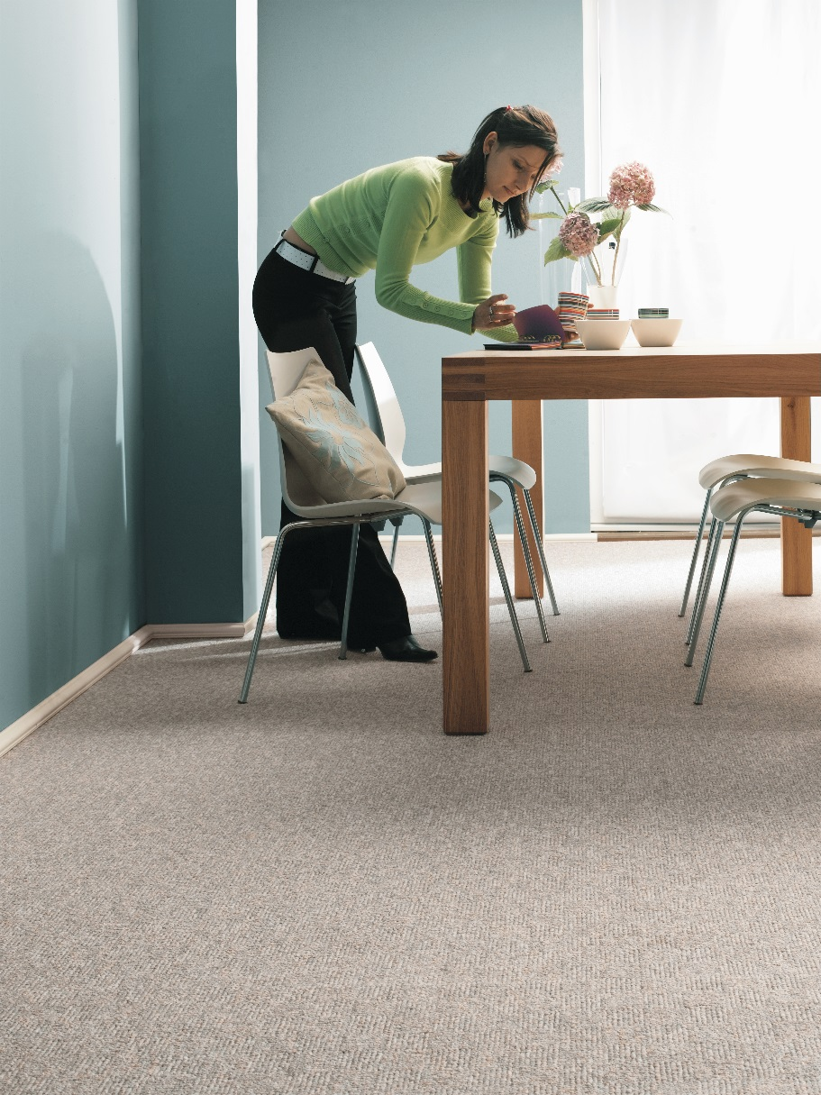
Manufacturing process
Tufting 1/4” loop pile
Pile content
85 % PP/ 15 % PA
Primary backing
Woven PP
Secondary backing
Twinback
Pile weight
Ca 950 gr./m²
Total weight
Ca 2.250 gr./m²
Pile height
Ca 5,5 mm
Total height
Ca 8,5 mm
Tuft density/m²
Ca 58 100
Width
400 + 500 cm
Sound insulation
24 dB
Fire class
Cfl-s1 (EN 13501-1)
