Nevada

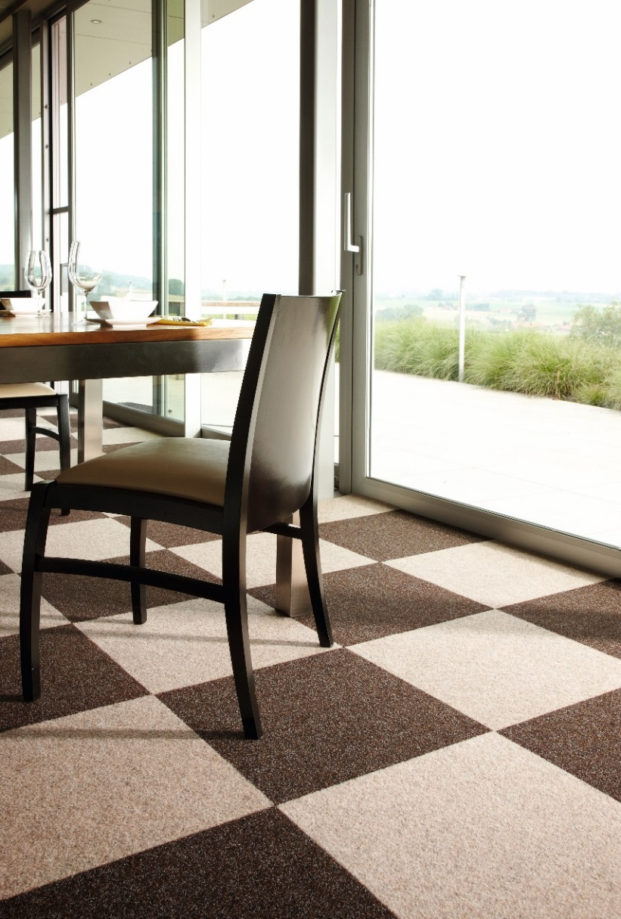
Manufacturing process
1/10” Tufted loop pile
Pile content
100 % Polyamid
Primary backing
Bitumen
Pile weight
ca. 550 gr./m²
Total weight
ca. 4.000 gr./m²
Pile height
ca. 3 mm
Total height
ca. 5 mm
Tuft density/m²
ca. 177 750
Size
50 x 50 cm

