Panorama

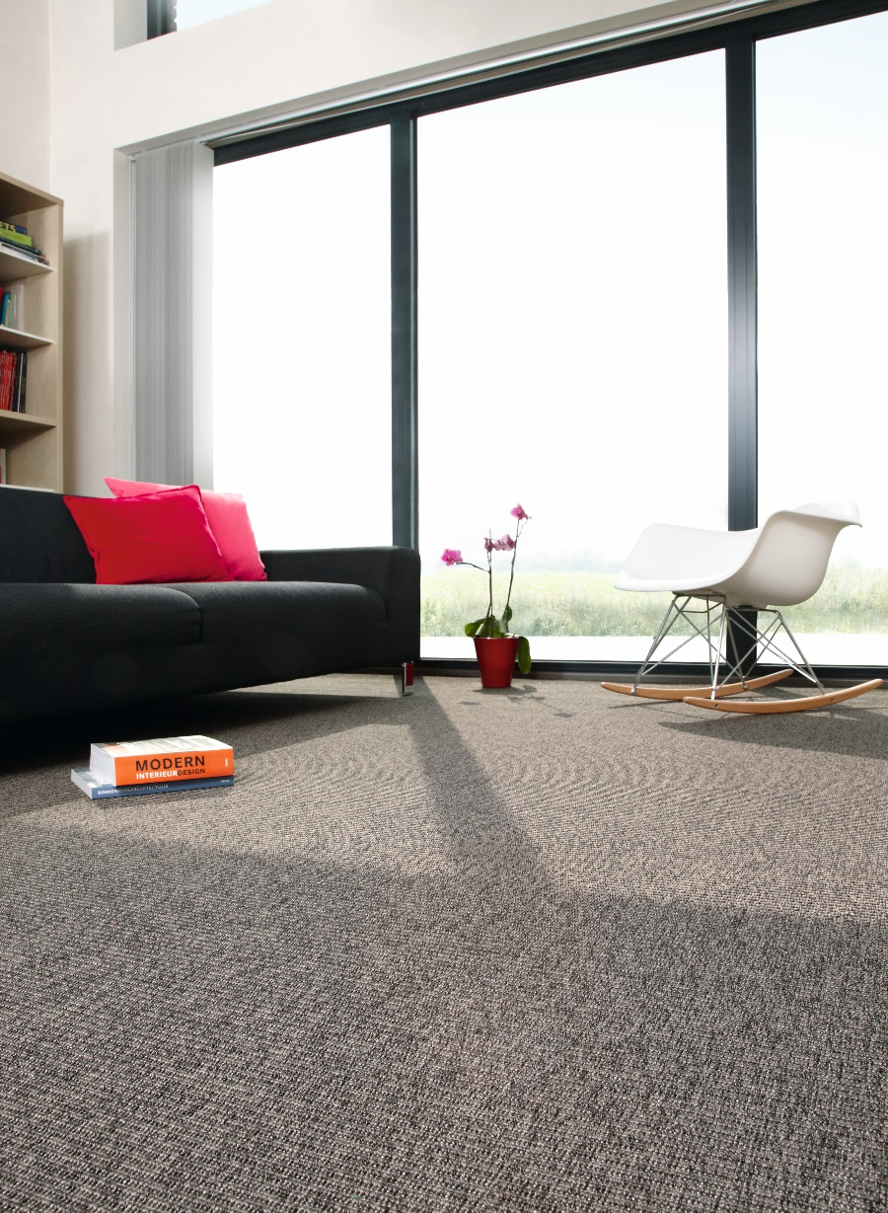
Manufacturing process
5/32” Bouclé
Pile content
100 % PP
Backing
Felt
Pile weight
ca 450 gr./m²
Total weight
ca 1.278 gr./m²
Pile height
ca 3 mm
Total height
ca 5 mm
Tuft density
ca 107 100/m²
Width
400 + 500 cm

