Rapid

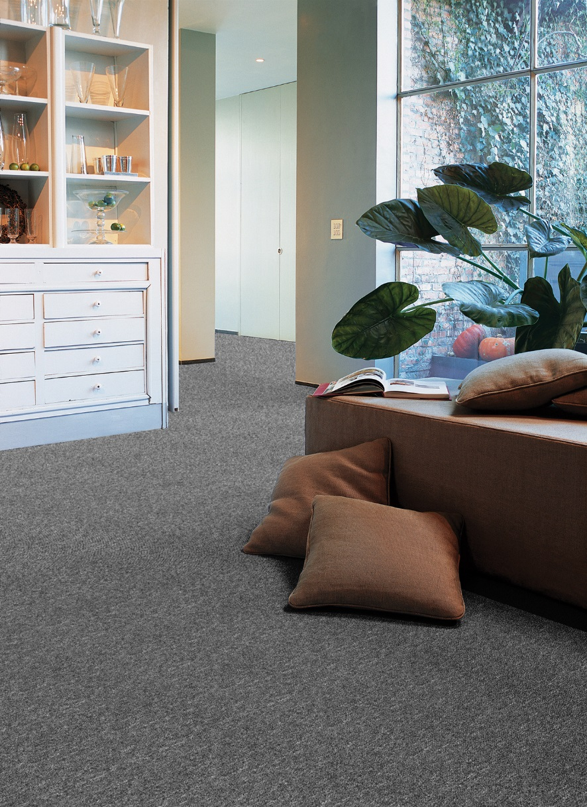
Manufacturing process
Tufting 1/10” loop pile
Pile content
100 % PP
Backing
Felt
Pile weight
ca 330 gr./m²
Total weight
ca 1050 gr./m²
Pile height
ca 5 mm
Total height
ca 6,5 mm
Tuft density
ca 118 500/m²
Width
400 + 500 cm (ant+grå)
Fire class
Efl (EN 13501-1)

