Robust

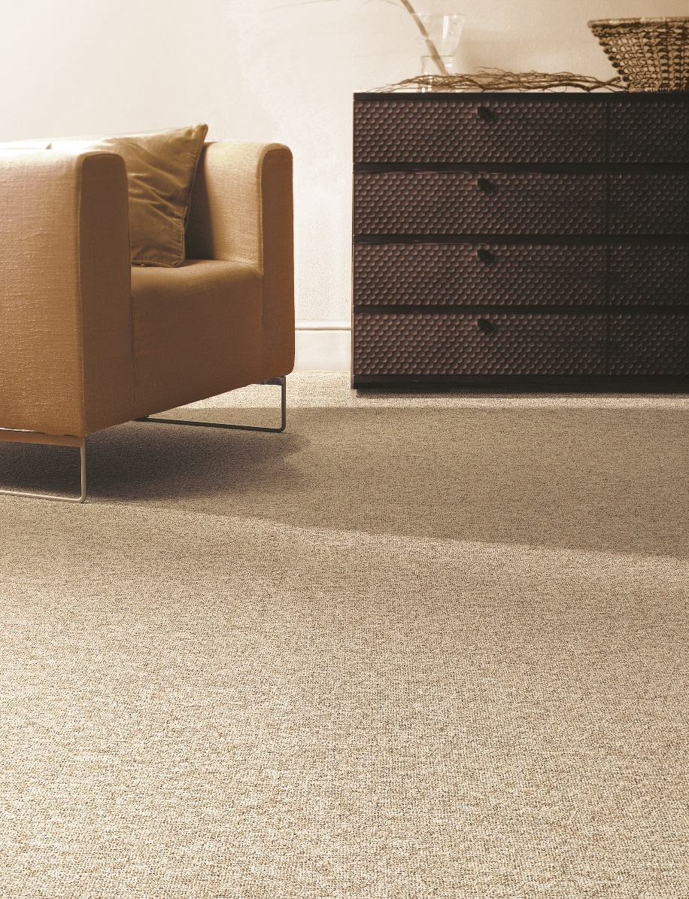
Manufacturing process
1/10” loop pile
Pile content
50 % PA/ 50 % PP
Primary backing
Ultratex
Pile weight
± 700 gr./m²
Total weight
± 1.950 gr./m²
Pile height
± 4 mm
Total height
± 7 mm
Tuft density/m²
± 126 000
Width
300 + 400 + 500 cm
Sound insulation
± 24 dB
Fire class
Efl (EN 13501-1)

