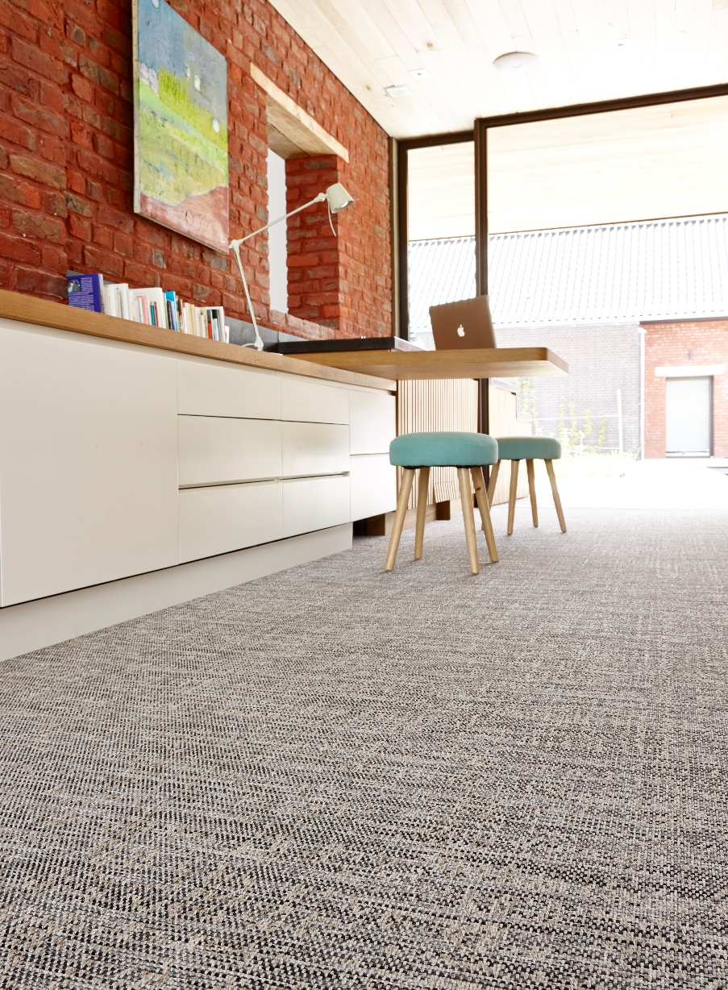
Samson
Manufacturing process
Nonwoven
Pile content
100 % PP
Backing
Gel
Pile weight
ca 1.250 gr./m²
Total weight
ca 1.830 gr./m²
Pile height
ca 4 mm / 7 mm
Total height
ca 6 mm / 10 mm
Width
200 cm

