Tango

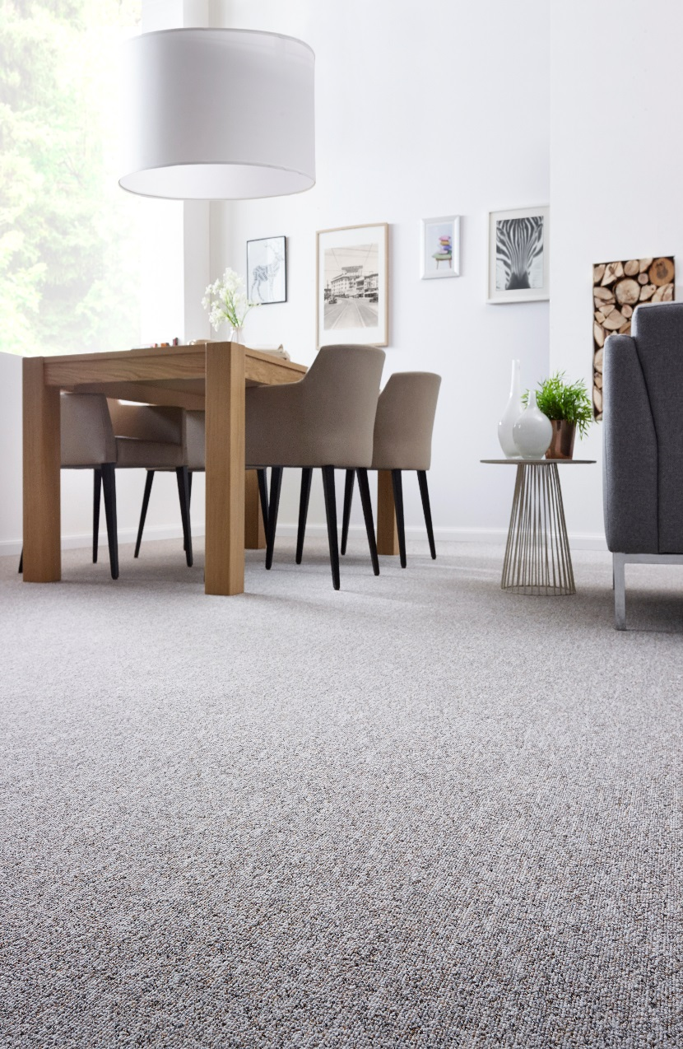
Manufacturing process
Tufting 1/4” loop pile
Pile content
100 % PP
Primary backing
Woven PP
Secondary backing
Latex foam
Pile weight
Ca. 600 gr./m²
Total weight
Ca. 1.800 gr./m²
Pile height
Ca. 5 mm
Total height
Ca. 8 mm
Tuft density/m²
Ca. 69 750
Width
400 + 500 cm
Sound insulation
22 dB
Fire class
Efl (EN 13501-1)

