Texas

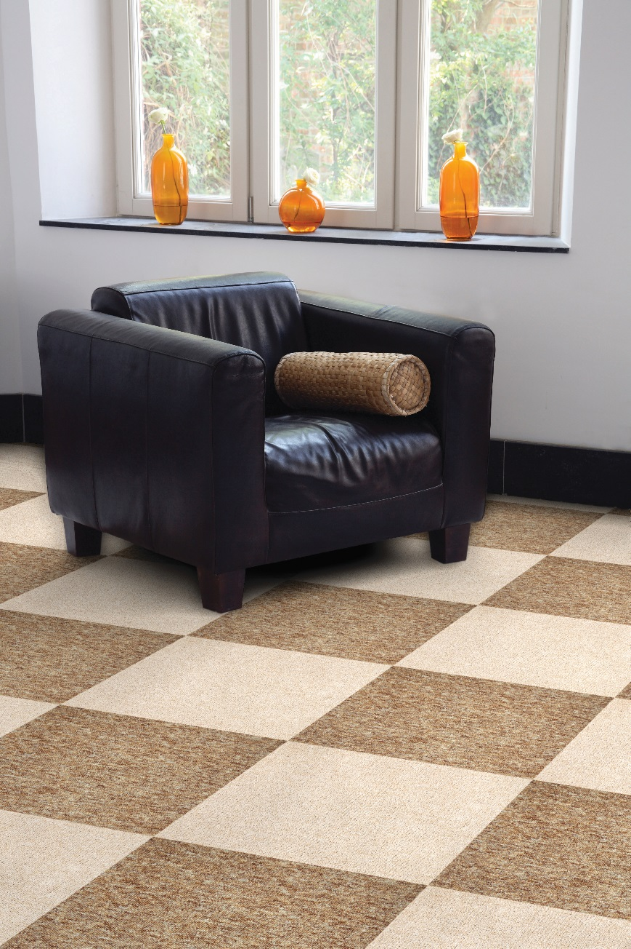
Manufacturing process
1/10” Tufted loop pile
Pile content
100 % PP
Primary backing
Bitumen
Pile weight
ca. 400 gr./m²
Total weight
ca. 3.700 gr./m²
Pile height
ca. 2,9 mm
Total height
ca. 5,9 mm
Size
50 x 50 cm
Fire class
Cfl-s1

