Timeless

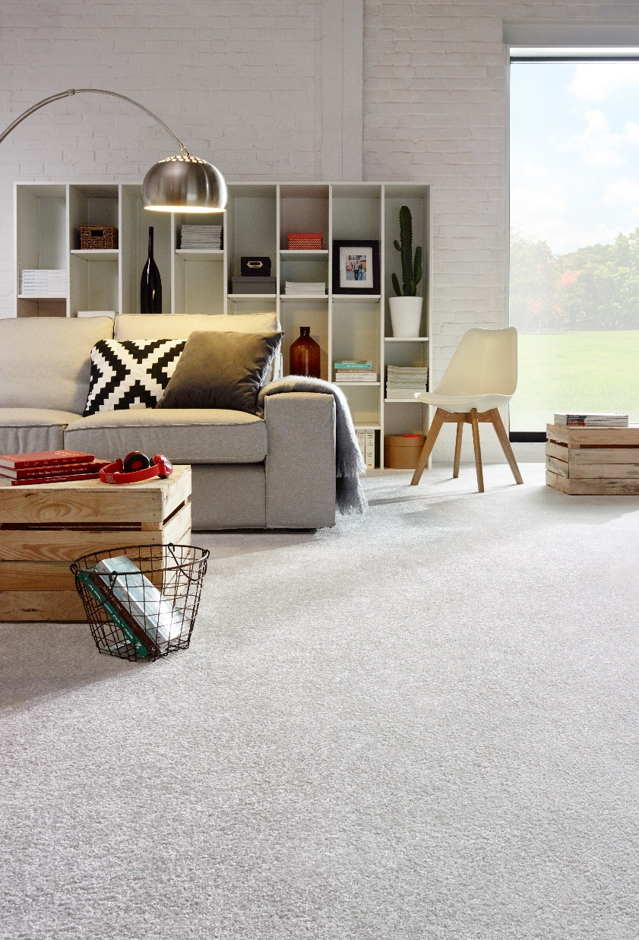
Manufacturing process
Tufting 1/8” cutpile
Pile content
100 % PP
Primary backing
Woven PP
Secondary backing
Synthetic backing
Pile weight
Ca 2.100 gr./m²
Total weight
Ca 2.945 gr./m²
Pile height
Ca 12 mm
Total height
Ca 15 mm
Tuft density
Ca 133 875/m²
Width
400 cm
Sound insulation
28 dB
Fire class
EN 13501-1

